

Brain tumor Detection using Support Vector Machine

**SUBMITTED TO :**

Dr. Ravi Kumar Jatoth

Professor , Department of Electronics & communication Engineering

**SUBMITTED BY:**

Malavika Dilu – 21ECB0F23

K. Abhinav Konda – 21ECB0F27

1. INTRODUCTION

A brain tumor occurs when abnormal cells form within the [brain](https://en.wikipedia.org/wiki/Human_brain). There are two main types of [tumors](https://en.wikipedia.org/wiki/Tumor): malignant tumors and [benign](https://en.wikipedia.org/wiki/Benign_tumor) (non-cancerous) tumors. These can be further classified as [primary tumors](https://en.wikipedia.org/wiki/Primary_tumor), which start within the brain, and [secondary](https://en.wikipedia.org/wiki/Metastasis) tumors, which most commonly have spread from tumors located outside the brain, known as [brain metastasis](https://en.wikipedia.org/wiki/Brain_metastasis) tumors. All types of brain tumors may produce symptoms that vary depending on the size of the tumor and the part of the brain that is involved. Where symptoms exist, they may include [headaches](https://en.wikipedia.org/wiki/Headaches), [seizures](https://en.wikipedia.org/wiki/Seizures), problems with [vision](https://en.wikipedia.org/wiki/Visual_perception), [vomiting](https://en.wikipedia.org/wiki/Vomiting) and [mental](https://en.wikipedia.org/wiki/Cognition) changes. Other symptoms may include difficulty walking, speaking, with sensations, or [unconsciousness](https://en.wikipedia.org/wiki/Unconsciousness).

The brain disease brain tumor is required to quantify as early as possible right from first stage of its occurrences. The Neurologist takes help regarding the quantification & rectification of such disease from the radiologist. In this aspect radiologist is the expert for taking the images of brain and also rectifies the data, which is forwarded to neurologist for treatment. In this paper a methodology to detect, quantify and also identify brain disease using the digital image processing is presented. The results are shown in order to clarify the methodology & experimental outputs which will be used by the radiologist, thus giving a second opinion to doctors for making the decisions.

* 1. PITUITARY TUMOR

Pituitary tumors are unusual growths that develop in the pituitary gland. This gland is an organ about the size of a pea. It's located behind the nose at the base of the brain. Some of these tumors cause the pituitary gland to make too much of certain hormones that control important body functions. Others can cause the pituitary gland to make too little of those hormones.

Most pituitary tumors are benign. That means they are not cancer. Not all pituitary tumors cause symptoms. Sometimes these tumors are found during an imaging test, such as an MRI or a CT scan, that is done for another reason.

Our project aims at detecting brain tumor, specifically pituitary brain tumor using SVM mechanism. The CT scan images of the tumor show the white spots in the middle of the grey matter when the tumor is of Grade I, and it is impossible to find this tumor in the brain by using the radiologist expertise as shown in figure 1.

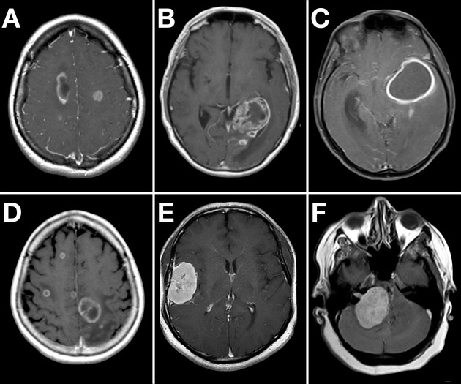

(CT scan images of brain with tumor)

1. PREVIOUS WORKS

A novel calculation was done by Bhattacharjee and Chakraborty (2012) to include out the tumor from sick mind with the help of Magnetic Resonance (MR) pictures. The research enlightens the value parameter correlation of two channels, a versatile middle channel is chosen for de-noising the pictures.

Chandra, Bhat and Singh (2009) has proposed a grouping calculation dependent on Particle Swarm Optimization (PSO). The calculation finds the centroids of many bunches, where each group clusters together cerebrum tumour designs, got from MR Images.

The research proposed by Dvorak, Kropatsch and Bartusek (2013) has been manages programmed mind tumor location in attractive resonant pictures. The identification depends on checking the left-right symmetry of the cerebrum, which is the suspicion for a solid mind. The calculation was tried by fivefold cross-approval system on 72 pictures of mind containing tumors and 131 images of the sound cerebrum. The proposed strategy achieves the true positive rate of 91.16% and the true negative rate of 94.68%.

In our project, a digital method for defining tumour region using Magnetic Resonance Imaging (MRI) images in the brain was presented. A classification of a tumor is done depending upon the normal and abnormal then further they have classified into a malignant and benignant tumour. It incorporates different algorithms for preprocessing, image segmentation, feature extraction and image classification using neural network techniques. Finally, the tumor area is specified by region of interest technique as a confirmation step.

1. PROPOSED SYSTEM

The dataset of CT Scan images of normal and abnormal images are collected. Total of 1401 images are collected from which 80:20 ratio is used for training the linear function support vector machine.

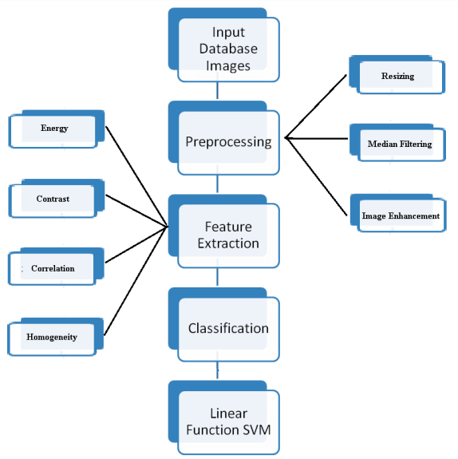

The input database image is preprocessed. Preprocessing like resizing, grayscale conversion, median filtering, image enhancement is carried out on the images.

Next stage is to extract the features from the database images. In all for the quantification of brain tumor 14 features are extracted from which 4 features shows the prominent change which can be used for the identification of brain tumor. The training of the classifiers is done with the database processed image and out of bag classification is done as shown.

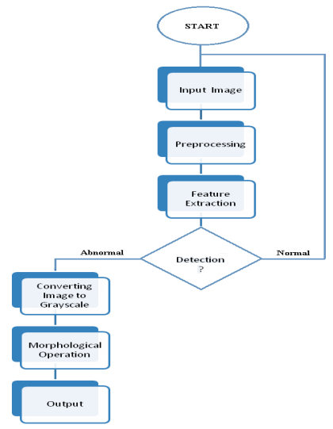

(Testing result for pituitary tumor)

1. DATA USED

In this project, we have used a total data of 1401 MRI scans out of which 1222 is for training (395 for no tumor and 827 for pituitary tumor) and 179 for testing (105 for no tumor and 74 for pituitary tumor).

We have downloaded and used our data from the data sets provided in kaggle. https://www.kaggle.com/sartajbhuvaji/brain-tumor-classification-mri

1. METHODOLOGY

* Import training data
* Assigning class 0 to no tumor and class 1 to pituitary tumor
* Resizing all the images to 200x200
* Calculating training accuracy
* Import testing data
* Resizing images
* Calculating testing accuracy

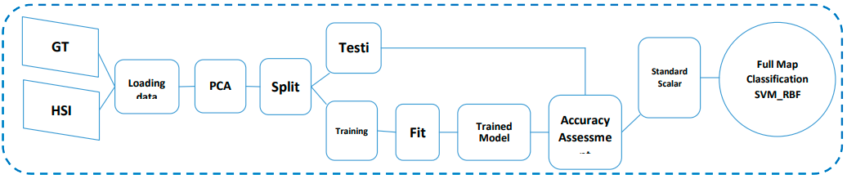

1. WHY SVM AND NOT LOGISTIC REGRESSION

Traditional statistical methods such as multivariate logistic regression intend to build a classification model that fits a set of patients (‘training’ set) optimally. Unfortunately, this strategy may easily result in a model that fits these training patients too well and is therefore not capable of making good predictions for previously unknown patients (‘independent’, ‘prospective’ or ‘test’ set). This problem is often referred to as overfitting the training patients, and leads to poor generalization to previously unknown patients. Support vector machines (SVMs) are a relatively new method based on the principle of statistical learning theory6 to solve classification and regression problems. This method tries to learn and generalize well when building a model using a given set of patients. This way, SVMs perform reasonably well on a training set, but not at the expense of performance when making predictions for previously unseen patients.

Logistic regression tries to fit a model as well as possible on the patients of the training set. Even with samples that do not follow the general underlying distribution in the case of outliers, logistic regression fits the training set too well, leading to a substantial number of misclassified patients when applied prospectively. SVMs try to generalize well when building a model using the given set of patients. With SVMs, optimization of the generalization performance is achieved by controlling two terms, i.e. by minimizing the classification error on the training set together with minimizing the complexity of the model. This trade-off is represented by a regularization parameter (γ) in the LS-SVM formulation.

A further disadvantage of logistic regression is that the technique is not able to identify possible nonlinear structures in a set of patients. When nonlinear relationships exist, a nonlinear decision boundary may result in a better performance overall. Unlike logistic regression, SVMs are designed to generate more complex decision boundaries. An LS-SVM with a simple linear kernel function corresponds to a linear decision boundary.

Instead of a linear kernel, more complex kernel functions, such as the commonly used RBF kernel, can be chosen. An RBF kernel requires optimization of the kernel parameter (σ), which controls the curvature of the decision boundary. Figure 1 shows an example in which using an SVM with an RBF kernel would be more appropriate than would using an LS-SVM with a simple linear kernel. With this more complex decision boundary, the nonlinearity in this set of patients could be better described than would be possible with a linear decision boundary.

SVM can also solve classification and regression problems with linear and non linear. SVR is an SVM method which is applied to the regression case. SVR aims to find a function f(x) as a hyperplane (separation line) in the form of a regression function which corresponds to all input data by making the smallest possible error. The parameters used in this SVM method include the value of C= 100, the value of gamma = 0.1, the value of epsilon = 0.05 and the type of kernel used is RBF (Radial Basis Function), as shown in the following formula:

𝐾 (𝑥, 𝑥′) = exp(−𝛾||𝑥 − 𝑥′||2) ........................................................................... (1)

Description:

K = kernel 𝛾 = gamma x, x’ = input x and y

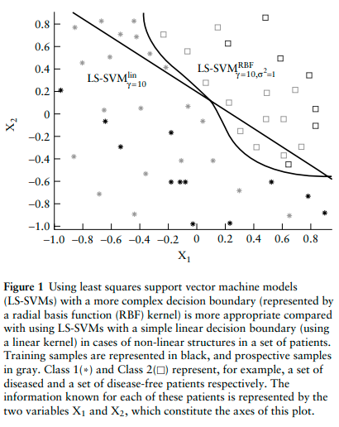

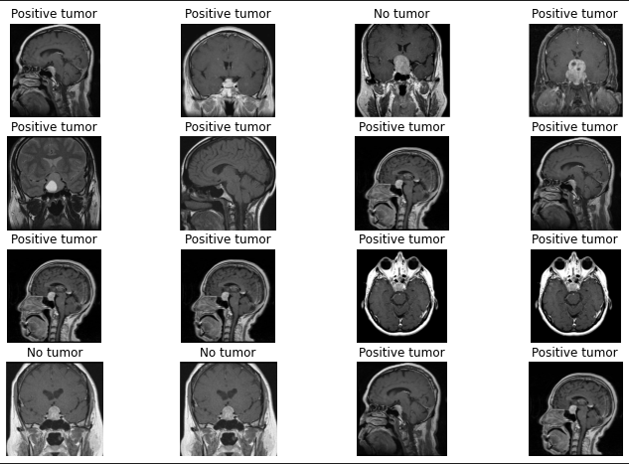

(testing results of pituitary tumor)

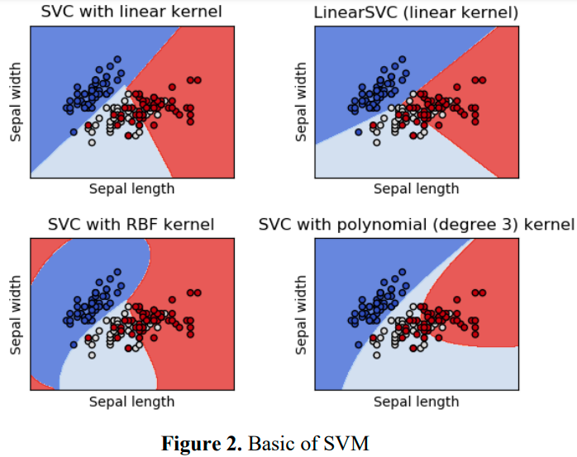

1. CONCLUSION

In our project we have successfully classified MRI images as tumors and no tumor using SVM and compared it with results obtained by the same using linear regression. We have found that even though logistic regression gives 100% accurate training score, it is better to use SVM as, in SVM the training and testing accuracy varies only by a marginal 3% whereas in linear regression it varies by 5%.

1. FUTURE SCOPE

We plan on expanding this project to detect as well as classify brain tumors and other diseases using SVM. Once the brain tumor is detected, it can be classified into its many types which can help doctors in its treatment.

1. REFERENCE

<https://www.mayoclinic.org/diseases-conditions/pituitary-tumors/symptoms-causes/syc-20350548>

<https://www.irjet.net/archives/V6/i12/IRJET-V6I12349.pdf>

<https://scikit-learn.org/stable/modules/svm.html>

<https://iocscience.org › mantik › article › download>

<https://obgyn.onlinelibrary.wiley.com/doi/pdf/10.1002/uog.2791#:~:text=Unlike%20logistic%20regression%2C%20SVMs%20are,RBF%20kernel%2C%20can%20be%20chosen>.

https://iopscience.iop.org/article/10.1088/1755-1315/357/1/012035/pdf#:~:text=Classification%20Accuracy%20of%20SVM%20and,to%20the%20big%20data%20hyperspectral